Project Proposal: Task Management System with Collaborative Features

**1. Introduction:**

In today's dynamic work environment, effective task management is crucial for ensuring productivity and achieving organizational goals. The proposed project aims to develop a Task Management System equipped with collaborative features to streamline task allocation, monitoring, and collaboration among team members.

**2. Objectives:**

* Create a user-friendly web-based platform for managing tasks.
* Enable users to create, assign, update, and delete tasks.
* Implement role-based access control to ensure data security.
* Facilitate collaboration by allowing team members to comment on tasks and share updates.
* Provide a centralized dashboard for real-time task tracking and monitoring.

**3. Features:**

**User Authentication:** Secure login system with username and password authentication.Role-based access control to differentiate between administrators and regular users.

**Task Management:** CRUD operations for tasks (Create, Read, Update, Delete).Ability to assign tasks to specific team members. Task prioritization and deadline setting.Task categorization and filtering options.

**Collaboration:** Commenting system to facilitate discussions on tasks.Real-time notifications for task updates and comments.File attachment feature for sharing relevant documents or resources.

**Dashboard and Reporting:** Dashboard providing an overview of all tasks, including their status and priority.Reporting tools to generate custom reports on task progress and team performance.Visual representations such as charts and graphs for better data visualization.

**4. Database Structure Description:**

**User Table**: Stores user credentials and roles for accessing the task management system. Will have a one-to-many association with the Task table for task assignments and with the Comment table for comment authorship.

**Task Table:** Manages task-related information including title, description, priority, deadline, status, and assignment. Will have a many-to-one association with the User table for task assignment and a one-to-many association with the Comment table for comment tracking.

**Comment Table:** Stores comments made by users on tasks, providing insights and discussions related to task activities. Will have a many-to-one association with both the User table for comment authorship and the Task table for task association.

**Categories Table:** Stores categories of task with their id and name. This table has a one-to-many relationship with Task table for deciding which task should go into which category.

**Task Management System ERD**

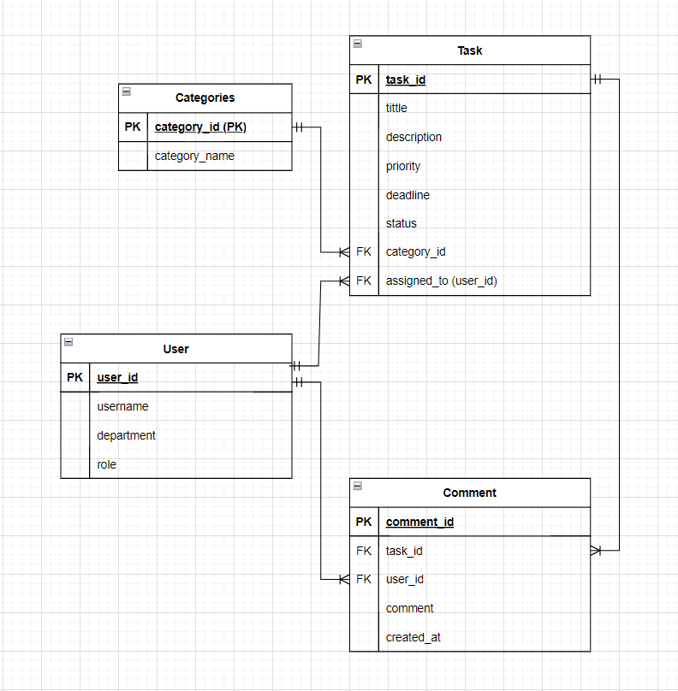

**5. Implementation Plan:**

**Database Design:** Design the database schema to store user information, tasks, comments, etc.

**User Authentication**: Implement a secure login system using PHP and MySQL.

**Task Management:** Develop functionality for creating, updating, and deleting tasks.

**Collaboration Features:** Integrate commenting system and real-time notifications.

Dashboard and Reporting: Design and implement the dashboard for task tracking and reporting.

**Testing and Debugging:** Conduct thorough testing to ensure system reliability and performance.

**Deployment:** Deploy the application on a web server and make it accessible to users.

**6. Technology Stack:**

Frontend: HTML, CSS, JavaScript, Bootstrap for responsive design.

Backend: PHP for server-side scripting.

Database: MySQL for data storage.

Additional Tools: phpMyAdmin for database management.